Task 0 : Explain what you are doing/ going to accomplish

I am going to create a page that allows the “shop owner” to add stock to a book, or add an entirely new book. This ideally will eventually be behing a sign in page as it is “sensitive” information. However for now I will make it part of the main page.

Task 1: Sketch interface design

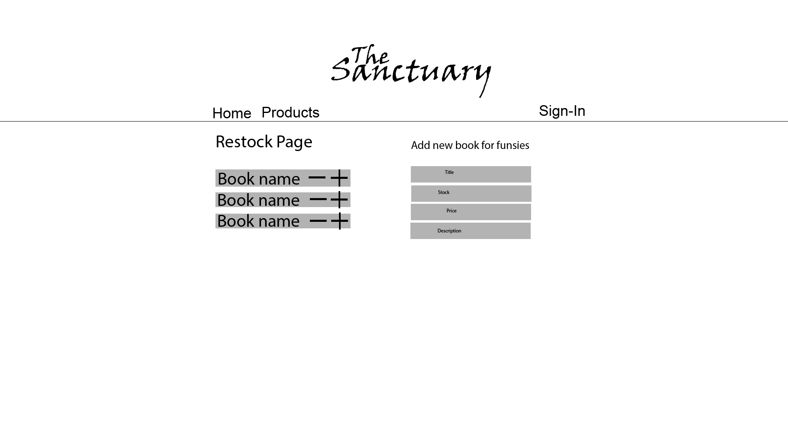

*Draft a rough design for the interface that allows the user to trigger functionality in task 1, while also annotating where the information in task 2 will be displayed. Create another sketch listing the interface widgets used to create the interface.*

Task 2: Identify any classes required

*Explain what the class will represent, plus listing what information will be stored in the class and any functions the class will have.*

Class Comic

Task 3: Identify information to be displayed

*What information will the interface need to display to the user?*

Display comic.title

Task 4: Identify user inputs

*What program functions can the user trigger through the interface?*

User inputs

Title

Stock

Price

Description

Task 5: Identify any constants or existing data if required

None

Task 6: Identify indexed data structures

comicBooks dictionary will be used to access comics

Task 7: Determine what calculations are necessary

*Write out the calculations the program will have to compute.*

None

Task 8: Develop a modular structure for your program

*Describe any functions that the computer program will have, identifying any sub-functions where required.*

Def restock_page():

Take in the inputs and create a new comic object

Task 9: Define the functions identified

*Describe the functions for both the main program and any classes in terms of input and/or output where required. You may choose to do this with flow charts or pseudo-code (not Python code!). Add in additional steps or explanations using sequential, conditional, iterative statements where required. Identify global and/or local variables.*

DEFINE restock_page with the method POST

USE title, stoc, price etc to creat new COMIC obeject with these paramaters

ADD comic to comicBooks dictionary

IF plus button is clicked,

Add 1 to stock of the comic

Task 10: Address any relevant implications such as usability, functionality, legal/ethical requirements.

Same design as other pages in order to continue with design language of the website.

Task 11: Document test cases for testing the program

*Document any testing that can be used to test your program. If any input is inputted using the keyboard, describe the expected input, plus any exceptional, boundary or invalid cases.*

Does it work and add the new comic to the system

Task 12: Refine the plan

*Note any modifications here when iterating through the development cycles.*

Task 13: Document testing

*Show screenshots of your program working with descriptions of each image. These images should test the tests cases listed above.*